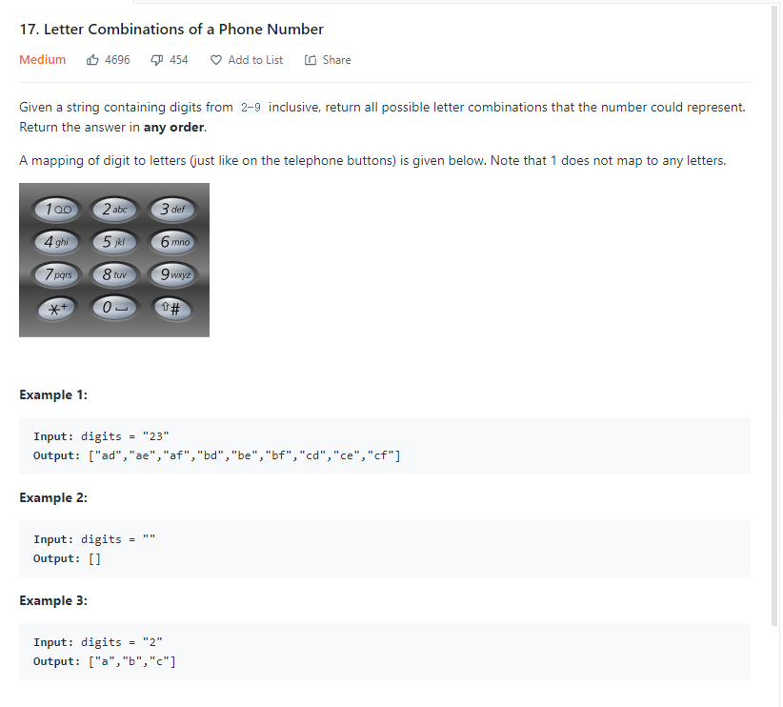

思路：看recursion总结

为啥他是recursion，因为第三次位数是加在第二位数排列组合上的，满足参与运算的结果与上一次调用有关

有边界

画图辅助思路

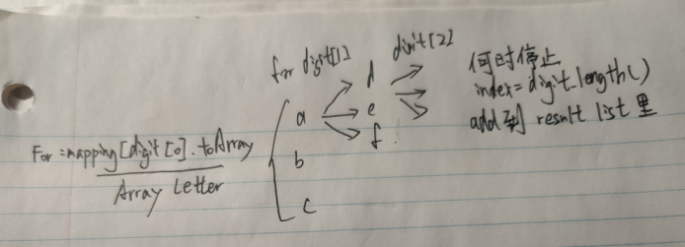

class Solution {

public List<String> letterCombinations(String digits) {

List<String> result=new ArrayList<String>();

if(digits==null||digits.length()==0) return result;

String[] mapping={

"0","1","abc","def","ghi","jkl","mno","pqrs","tuv","wxyz"

};

letterCombinationsRecursive(result,digits,mapping,"",0);

return result;

}

//按照recursion结构，前面只是用作一个main driver,准备好该用的基本条件

public void letterCombinationsRecursive(List<String> result,String digits, String[] mapping, String current, int index){

if (index==digits.length()){

result.add(current);

return;

}

String letters=mapping[digits.charAt(index)-'0'];

for(int i=0;i<letters.length();i++)

letterCombinationsRecursive(result,digits,mapping,current+letters.charAt(i),index+1);

}

//看图

}